Worksheet 2.4

Student Name: Sahil Kaundal UID: 21BCS8197

Branch: CSE (Lateral Entry) Section/Group:20BCS-807_B Semester: 4th Date of Performance: 31/03/2022

Subject Name: Programming in Python Lab Subject Code: 20CSP-259

1. Aim/Overview of the practical:

* Write a Python program to replace last value of tuples in a list.
* Write a Python program to remove an empty tuple(s) from a list of tuples.
* Write a Python program calculate the product, multiplying all the numbers of a given tuple.
* Write a Python program to convert a tuple of string values to a tuple of integer values.
* Write a Python program to check if a specified element presents in a tuple of tuples

1. Task to be done/ Which logistics used:



* Write a Python program to replace last value of tuples in a list.

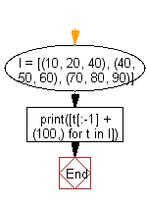

* Write a Python program to remove an empty tuple(s) from a list of tuples.

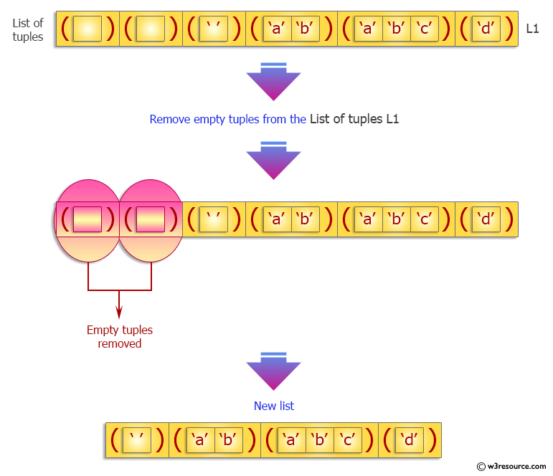

* Write a Python program calculate the product, multiplying all the numbers of a given tuple.

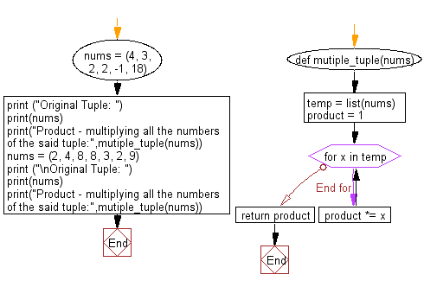

* Write a Python program to convert a tuple of string values to a tuple of integer values.

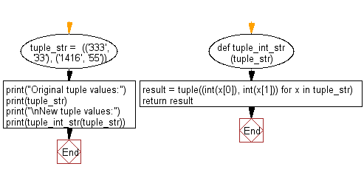

* Write a Python program to check if a specified element presents in a tuple of tuples.

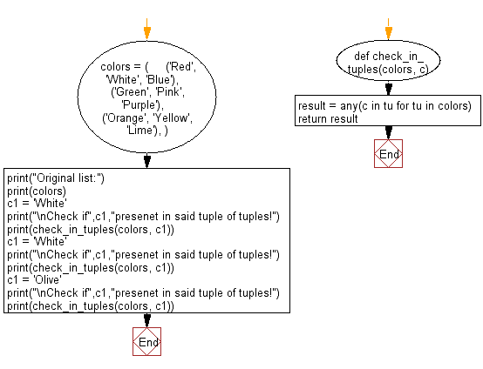

1. Steps for experiment/practical/Code:

* Write a Python program to replace last value of tuples in a list.

l = [(10, 20, 40), (40, 50, 60), (70, 80, 90)]

print(“The replaced last value of tuples in a list are: ”)

print([t[:-1] + (30,) for t in l])

* Write a Python program to remove an empty tuple(s) from a list of tuples.

Emplist = [(), (), ('',), ('a', 'b'), ('a', 'b', 'c'), ('d')]

Emplist = [t for t in Emplist if t]

print(“The elements after remove an empty tuple(s) from a list of tuples are:”)

print(**Emplist**)

* Write a Python program calculate the product, multiplying all the numbers of a given tuple.

def mutiple_tuple(nums):

temp = list(nums)

product = 1

for x in temp:

product *= x

return product

nums = (4, 3, 2, 2, -1, 18)

print ("Original Tuple: ")

print(nums)

print("Product - multiplying all the numbers of the said tuple:",mutiple_tuple(nums))

nums = (2, 4, 8, 8, 3, 2, 9)

print ("\nOriginal Tuple: ")

print(nums)

print("Product - multiplying all the numbers of the said tuple:",mutiple_tuple(nums))

* Write a Python program to convert a tuple of string values to a tuple of integer values.

def tuple_int_str(tuple_str):

result = tuple((int(x[0]), int(x[1])) for x in tuple_str)

return result

tuple_str = (('333', '33'), ('1416', '55'))

print("Original tuple values:")

print(tuple_str)

print("\nNew tuple values:")

print(tuple_int_str(tuple_str))

* Write a Python program to check if a specified element presents in a tuple of tuples

def check_in_tuples(colors, c):

result = any(c in tu for tu in colors)

return result

colors = (

('Red', 'White', 'Blue'),

('Green', 'Pink', 'Purple'),

('Orange', 'Yellow', 'Lime'),

)

print("Original list:")

print(colors)

c1 = 'White'

print("\nCheck if",c1,"presenet in said tuple of tuples!")

print(check_in_tuples(colors, c1))

c1 = 'White'

print("\nCheck if",c1,"presenet in said tuple of tuples!")

print(check_in_tuples(colors, c1))

c1 = 'Olive'

print("\nCheck if",c1,"presenet in said tuple of tuples!")

print(check_in_tuples(colors, c1))

1. Result/Output/Writing Summary:

* Write a Python program to replace last value of tuples in a list.

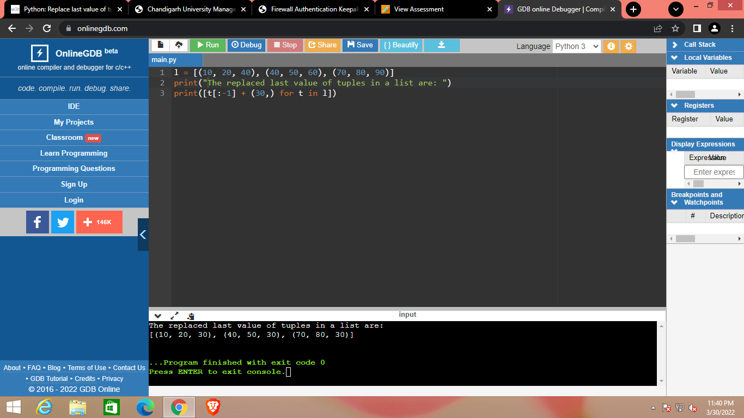

* Write a Python program to remove an empty tuple(s) from a list of tuples.

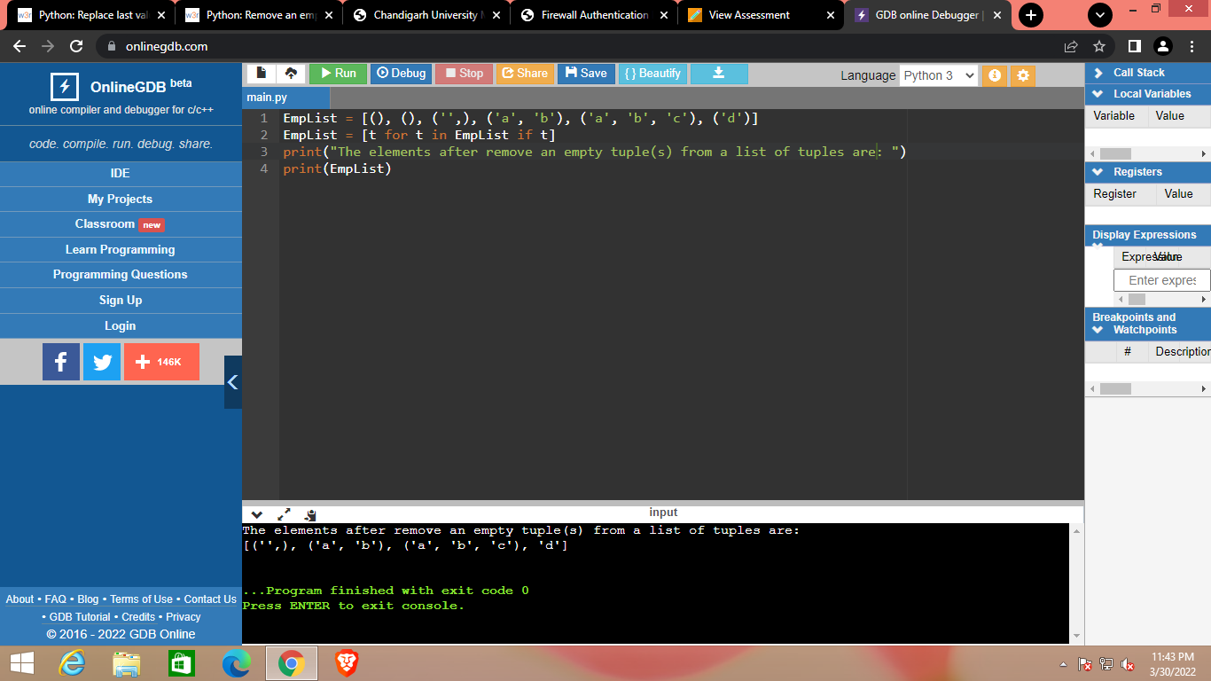

* Write a Python program calculate the product, multiplying all the numbers of a given tuple.

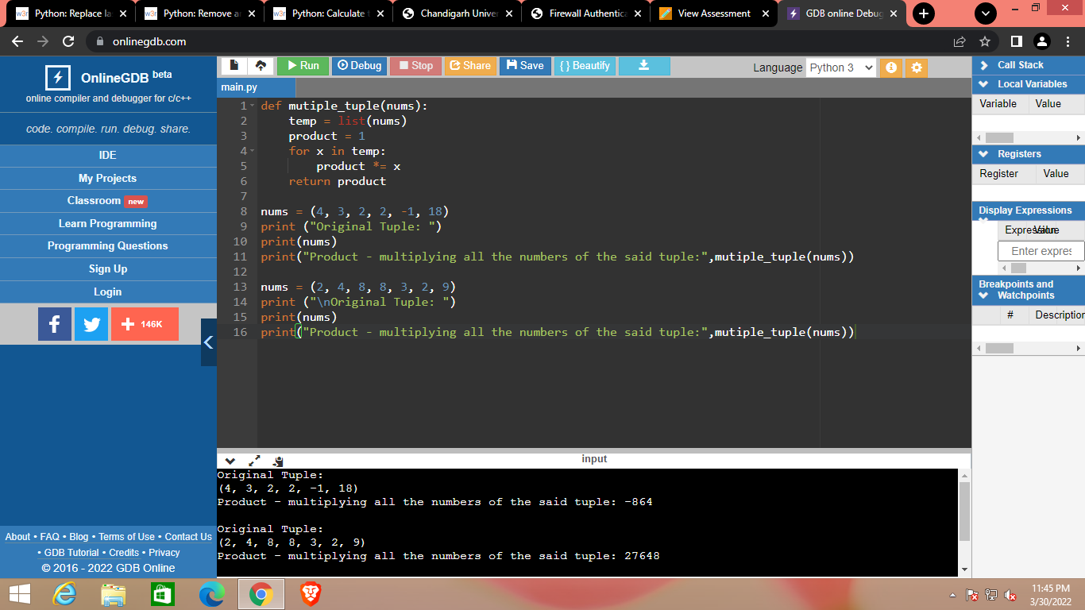

* Write a Python program to convert a tuple of string values to a tuple of integer values.

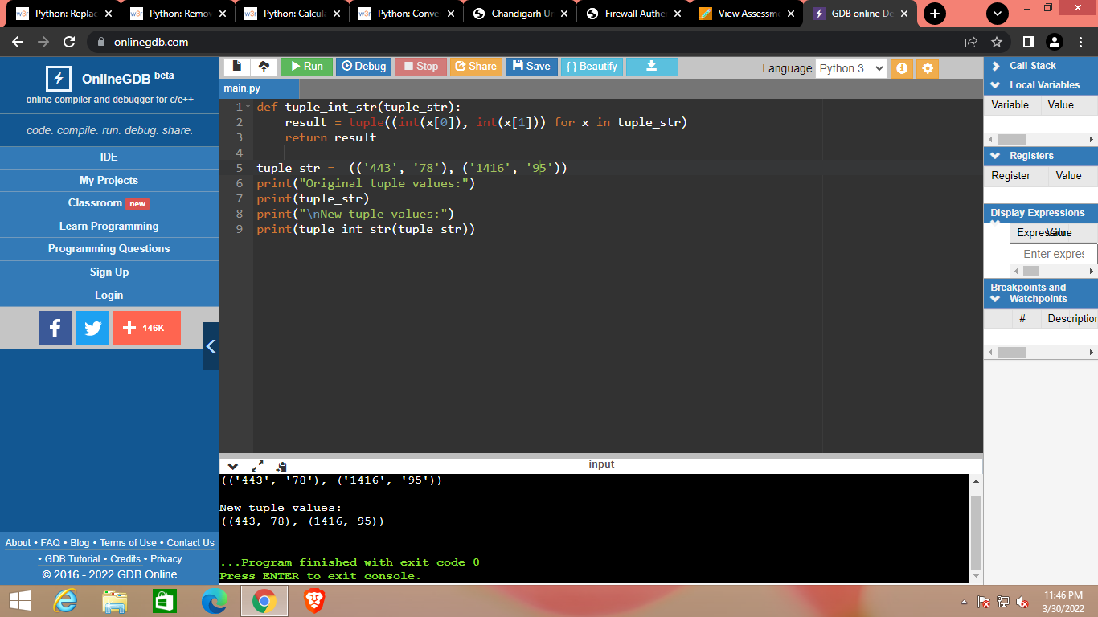

* Write a Python program to check if a specified element presents in a tuple of tuples

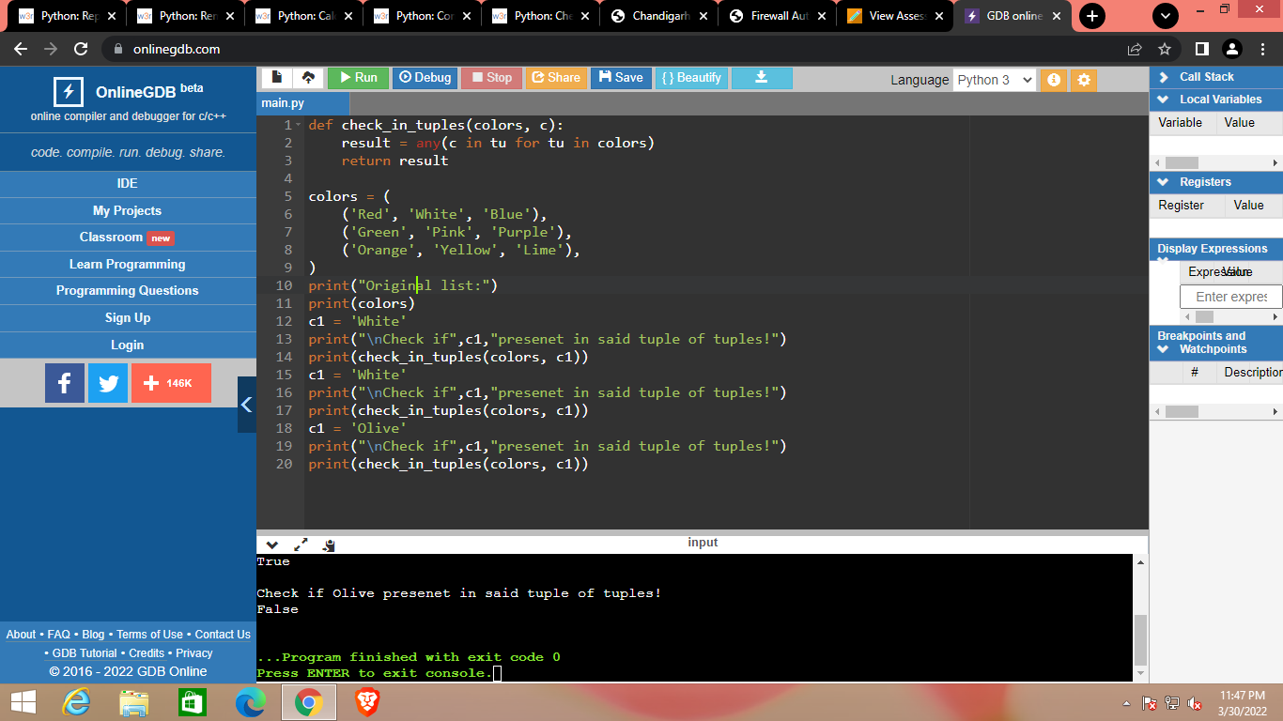

Learning outcomes (What I have learnt):

1. Python program to replace last value of tuples in a list.
2. Python program to remove an empty tuple(s) from a list of tuples.
3. Python program calculate the product, multiplying all the numbers of a given tuple.
4. Python program to convert a tuple of string values to a tuple of integer values.
5. Python program to check if a specified element presents in a tuple of tuples

Evaluation Grid (To be created as per the SOP and Assessment guidelines by the faculty):



|  |  |  |  |
| --- | --- | --- | --- |
| Sr. No. | Parameters | Marks Obtained | Maximum Marks |
| 1. |  |  |  |
| 2. |  |  |  |
| 3. |  |  |  |